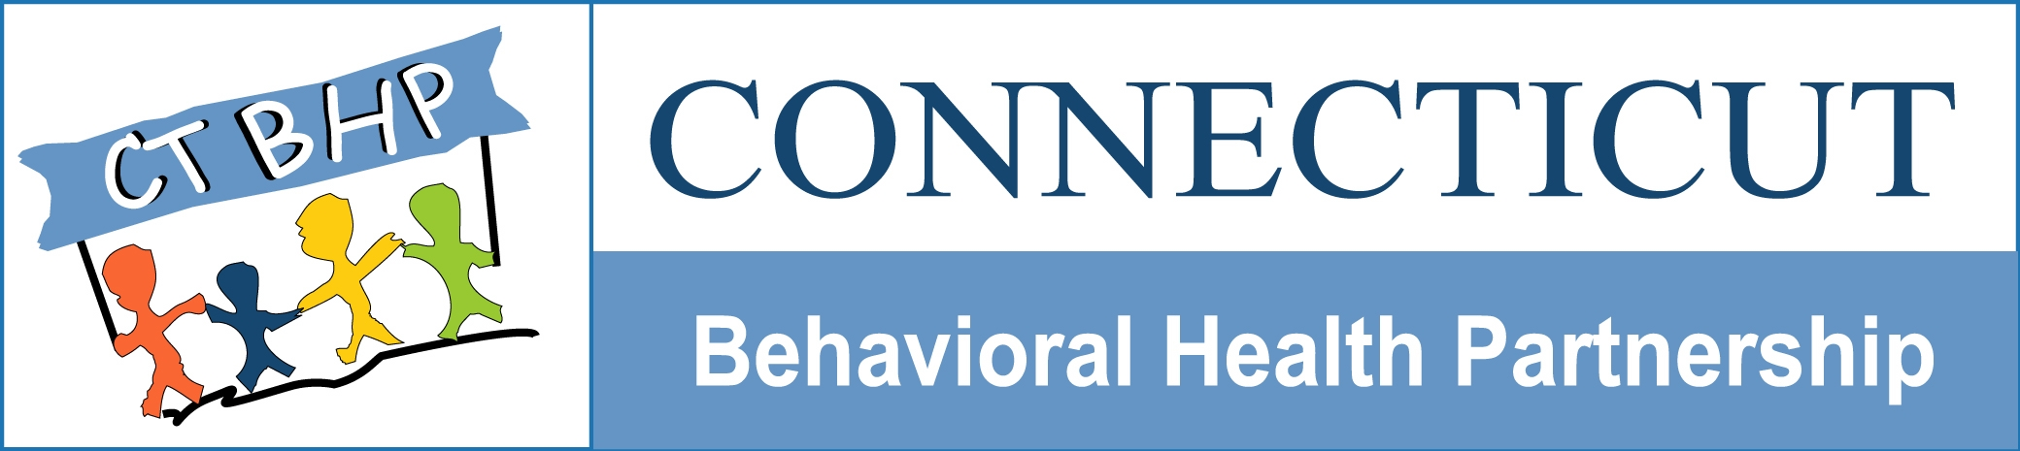

Highlights of Systems Change for Residential and Group Home Treatment

October, 2006

The Department of Children and Families, in collaboration with the Department of Social Services has procured the services of an Administrative Services Organization (ASO) to help oversee and manage the behavioral health system in Connecticut for HUSKY A children and adults, HUSKY B children and selected non HUSKY eligible children who are DCF involved and who have complex behavioral health needs. ValueOptions, Inc. is the agency contracted by the Departments to provide clinical management, utilization management and quality assurance to these publicly funded behavioral health services. Together, DCF, DSS and ValueOptions (the ASO) form the Connecticut Behavioral Health Partnership. To accomplish the goals within the Partnership which include increased access to needed services, greater focus on treatment and discharge planning, community focus and consumer/caregiver involvement, VO brings to the CT BPHP an advanced information technology that will allow the Partnership to better track and monitor the care its members receive.

Children in the care and custody of DCF present with some of the most complex and challenging behavioral health needs within the general population. Often, restrictive forms of treatment are required to address their issues (i.e, inpatient and residential treatment). These service types are costly and necessarily restrict the child’s ability to function within a normalized environment. As such, these interventions are to be used cautiously, and only when clinically indicated. The ASO has been provided with a set of prescribed guidelines to be used by its care management staff to determine appropriateness of entry into and continued stay within many service types, including inpatient, residential and group home care (levels I and II). These guidelines and others can be accessed on the CTBHP website at www.ctbhp.com. (see information for providers and then “level of care guidelines”) and were developed with input from DCF staff, providers and consumers. In addition, they have been approved and their use directed by the Legislatively mandated Behavioral Health Oversight Council.

The ASO has the ability to develop and implement a sophisticated set of data bases that will be able to identify vacancies within our network of Residential (and Group Home) providers and match children who meet clinical criteria for these levels of care against the services and curricula offered within the facilities. The ability to efficiently and effectively match children to the appropriate RTC or Group Home service depends on the implementation of a more automated way of collecting information from both providers and from referral sources. The ASO has been working since February, 2006 to collect detailed information from our existing Residential and Group Home providers to populate their Provider data base. We are now introducing a way to enhance the collection of clinical information on the children referred for RTC and Group Homes so that we can capitalize on the technology the ASO affords us. The attached table outlines the notable changes in protocols and procedures that DCF is implementing to achieve greater efficiency within the existing CPT process.

