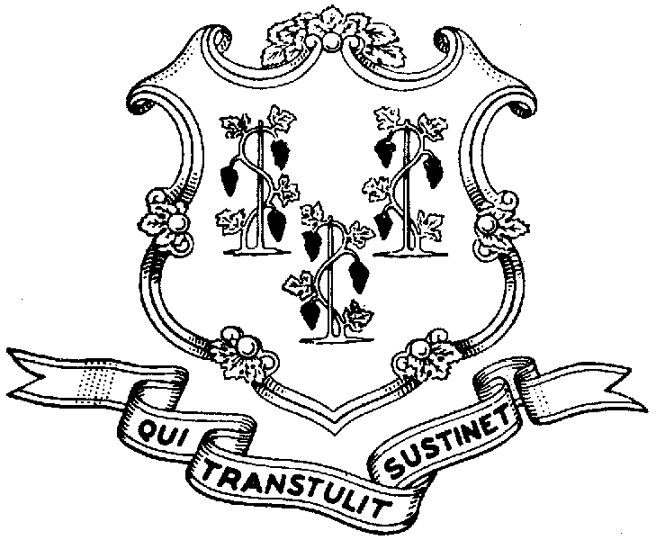
Behavioral Health Partnership Oversight Council
Provider Advisory Subcommittee
Legislative Office Building Room 3000, Hartford CT 06106
(860) 240-0321 Info Line (860) 240-8329 FAX (860) 240-5306
www.cga.ct.gov/ph/BHPOC

Meeting Summary: November 14, 2007
Chair: Susan Walkama

Cares Unit Level of Care Guidelines

Lois Berkowitz (DCF) described the CARES Unit, a hospital-based program, that will provide services to HUSKY and commercial members (see description in above documents).
- Who will be served by the Unit: those pediatric psychiatric clients that are deemed appropriate for brief intensive evaluation in a secure place and/or 24 hour inpatient stabilization. The length of stay is expected to be 72 hours (stays beyond that will not be paid).
- Purpose of the unit is to reduce ED gridlock. This Unit, the only one in the state, will be taking only children residing in the “Hartford area”.
- The Unit, opened Oct. 15th, has had 50 children/youth in 24 hour care, with an ALOS of 2.8 days and outlier stay of 12 days.

Discussion of the guidelines:

- It was clear from the discussion that there was some confusion about the two LOC guidelines. It was suggested that:
  - The two (evaluation and admission) be put into one guideline.
  - Prior to presenting the guidelines to the BHP OC for consideration in December, a CARES Unit representative should describe the services to the full Council.
- Important to define what the CARES is not. Outreach to the community needs to emphasize that:
  - The Unit is not a “walk-in crisis service”. Schools and others should still use the EMPS system as a primary crisis resource.
  - Longer crisis stabilization services are available (i.e. Wheeler Clinic Greenhouse program). The LOS for these services could be 14 days.

The revised guidelines will be presented to the BHP OC in December along with a description of the program.

